Smart Sanitization Robot

Krimy Shah
Department of Information Technology
SVKM’s NMIMS University, Mukesh Patel School of Technology Management & Engineering
Mumbai, India
krimy.shah19@nmims.in

Tirth Mehta
Department of Information Technology
SVKM’s NMIMS University, Mukesh Patel School of Technology Management & Engineering
Mumbai, India
tirth.mehta18@nmims.in

Abstract- The Smart Sanitization Robot is an autonomous disinfectant system designed to improve hygiene standards in healthcare and public environments by minimizing human involvement in the sanitization process. This robot is based on a dual-controller architecture using ESP32 and Arduino Uno microcontroller, and together with various sensors, such as ultrasonic sensor, PIR sensor, IR obstacle sensor, DHT11 sensor, line-following sensor, and water-level sensor, the robot can intelligently move around, sense surroundings, and apply the ability to control water disinfection. The robot automatically sprays disinfectant in unoccupied areas, ensuring safety, uniform coverage, and reduced chemical usage.Two relay-controlled water pumps and an L293D motor driver manage motion and spraying functions. Real-time IoT connectivity through the ESP32 enables monitoring, control, and performance analysis via dashboards. Experimental results demonstrate over 90% disinfection efficiency, uniform surface coverage, and a significant reduction in manual labor and chemical waste. The proposed model offers a secure, cost-effective, and scalable solution for continuous and contactless sanitization, contributing to the development of intelligent, sustainable, and infection-resistant healthcare environments.

Keywords- Smart Sanitization Robot, Automation, Healthcare Robotics, Contactless Sanitization, Sensor Integration, Real-Time Monitoring, Surface Disinfection.

INTRODUCTION
Healthcare-associated infections (HAIs) are one of the most persistent and challenging issues and that are difficult to address in healthcare systems across the globe. These infections are acquired at the time the patients are in the hospitals or other health facilities hence have contributed to the morbidity and mortality rates of patients [1]. According to the WHO, millions of patients globally are affected1 to HAIs yearly, and consequently, not only serious health outcomes are observed in patients, but also considerable financial losses in healthcare institutions and health insurance funds on the state level [1], [2]. Hospital surfaces, equipment, and hands of healthcare workers are left to be a significant source of these infections due to the presence of pathogenic microorganisms on them. Once in any clinical environment, pathogens can lead to a rapid transmission of contaminated surfaces on patients, workers, and visitors provoking the process of infection cycles that can hardly be halted [2], [3].
The most alarming fact about HAIs is that there are pathogens on high contact surfaces such as door handles, bed rails, trolleys, switchboards, and nursing stations [2]. Such types of microorganisms that have been found on these surfaces are Staphylococcus aureus, Escherichia coli, and Pseudomonas aeruginosa, most of which are multidrug-resistant [3]. Studies have also revealed that certain species of bacteria spores can take weeks or even months to dry up yet still able to cause infections [3], [4]. Medical institutions are active organizations and since they are subject to human traffic, all their contact points can be considered potential locations of cross-contamination. Thus, even the smallest breach of the surface disinfection can give rise to the outbreak that is going to pose the threat to the lives of patients and the hospital image [2].
In order to overcome this, hospitals worldwide have employed various sanitization means which include alcohol-based antiseptics, chlorine water, ultraviolet (UV) radiations and airflow cleaners [4], [5]. Though these conventional disinfection interventions have been widely used and to a lesser degree they work well, they are highly reliant on human beings and manual labor [4]. In practice, this dependency causes the fluctuation of the outcomes since the performance of disinfection largely depends on the regularity and thoroughness of the cleaning personnel. Sanitization as a manual process though important is prone to human fatigue, coverage and monitoring that leaves untreated hotspots and further proliferation of the microbes [2], [5]. Besides this, majority of these disinfection processes lack real time validation mechanisms i.e. they lack real time immediate feedback/ confirmation that the target surfaces are reasonably disinfected [4]. This lack of inspection makes it hard to ensure that everything is clean especially when working with big medical centers where the employees have dozens of areas to clean in a severe time constraint.
Despite a long-term effort to attain hygiene, complete and periodic disinfection of multifaceted hospitals has not been fully realized yet [5]. This is due to the recurrent nature of HAIs, which is brought about by airborne transmission, contamination of surfaces and persistence of the pathogens in inaccessible corners. Additionally, there is a growing pressure within healthcare facilities to achieve maximum efficiency with regards to operating and reduction of operating costs, thereby leading to an increase in the need to create smart, automated and scalable sanitization solutions [6]. It is estimated that such systems will not only increase the performance cleaning but also reduce the human error, reduce the occupational risks in addition to delivering information-based data on the disinfection performance.

Disadvantages of Conventional Sanitization Techniques
Despite the fact that the hospital hygiene practices over the decades have been founded on the traditional cleaning and disinfection processes, the processes have a weakness line that has compromised their overall performance. The sanitization process carried by hand is not very uniform since it is largely dependent on the conscious and experience of the cleaning staff [2]. The human fatigue, time constraint, and psychological strain on a high-pressure hospital environment, which is experienced in the turnover between the admissions of patients being fast, could be a cause of poor disinfection. This renders certain ones ill treated abandoning the reservoirs of microbes that may lead to secondary infections [2], [4].
Other than the absence of consistency in operation, the manual cleaning is associated with chemical hazards to the workers. In the long-term, hospital workers have been exposed to strong disinfectants like chlorine, aldehydes, and phenolic compounds and associated with respiratory and eye and skin allergy [4]. These work hazards are not only associated with the health of the workers, but they also have the potential of increasing absenteeism and low productivity.
Such high inertia methods of disinfection as UV irradiation, chemical mist spraying are more or less automated, but they have the weakness to some extent. The areas that are not exposed or covered by the shadows of ultraviolet radiations cannot be penetrated by them and thus, create a microbial pocket [5]. Equally, mist or fog-based disinfectant system relies on the airflow pattern and the presence of unequal distribution may result in incomplete coverage [5]. Besides this, the other fact that active maintenance of disinfection schedules in big healthcare facilities consumes a lot of man power, supplies and financial resources that ultimately translate to high cost of operation [1].
Hospital environment is not a mere thing because it deals with patient wards, surgical theaters, labs and waiting areas and hence it is hard to maintain a specific level of hygiene. Any laxity in the cleaning schedule, either in the number of staff or time deficit, is also a threat of infection reoccurrence. As a result, although the chemistry of disinfection and technology of sterilization is already established, the problem of providing a continuous and effective and verifiable sanitization is to be confronted by the healthcare industry [6].
These disadvantages demonstrate that an extremely clear discrepancy exists between the existing way of sanitizing and the necessity of automated and smart disinfection tools that will be ready to conduct the repetitive disinfection programs without getting exhaustive, provide consistency in their coverage, and can execute their operations without human oversight.
- Sanitization System Requirement-Automated.
The concept of the automation technologies, and, specifically, the microcontrollers and the Internet of Things (IoT) [6], has made the new opportunities of bridging the gap of the traditional forms of sanitization. By incorporation of embedded systems in the healthcare processes, the real-time monitoring, adaptive control and automatic activation of disinfection process can be conducted based on the environmental factors. ESP32 is a future microcontroller that has been selected as a perfect candidate on the creation of automated sanitization systems considering that it is a microcontroller with dual-core processor, in-built Wi-Fi and Bluetooth modules and can be integrated with various kinds of sensors and actuators [7].
It has an automated sanitization system which can be embraced in case of automatic monitoring of the environmental parameters and status of the system through the incorporation of sensors, including ultrasonic sensors, infrared (IR) modules, passive infrared (PIR) motion sensors and water-level sensors among others [8]. To take motion sensors as an example, one can make sure that disinfection is done in vacant spaces only, and it increases the level of safety. The ultrasonic sensors are capable of measuring the distance to the surfaces, and regulate the power of spray and the water-level sensors can be utilized to regulate the supply of disinfectants such that the processes become continuous [8], [9].
The operation of such a system is usually activated by means of using the relay modules, solenoid valves and motor drivers to regulate the flow and direction of the disinfectant sprays [9]. This environment allows the right time and the right amount of disinfectant to be applied that is much more effective as compared to hand spraying. Furthermore, these sensors are capable of transmitting the raw data that they capture to the management dashboard of the hospital through the IoT networks so that the administrators were able to monitor the cleaning schedule, analyze the performance, and to plan the maintenance process.
The automated sanitization system based on ESP32, therefore, is multidimensional. It also improves efficiency of disinfection because it offers consistency to its use, it avoiding the risk of human error and work risks since the staff is not much exposed to the harmful substances [4], [6]. It is also cost effective as it minimizes on the use of the man power and may be grown based on size and requirements of the facility [10]. The complete automation of the sanitization process will enable hospitals to ensure the sterility at a much greater level and, in particular, in the high demand times (e.g. disease outbreak or pandemic).
The general initiation of the implementation of the IoT-based automation into the healthcare sanitization is a substantial move towards infection control. It provides that space between the manual and precision of technology, the cleanliness is ensured at all times, the safety is enhanced and the effectiveness of using the resources. The systems will not only be useful in supplementing the current practices of infection prevention but will also assist in the realization of the long-term perspective of smart hospitals where the technology is employed to improve the safety, efficacy, and sustainability of healthcare practices to the patient [6], [7], [10].

LITERATURE REVIEW

Autonomous UV-C Disinfection Robots
The medical institutions are always overwhelmed with drug resistant infections such as MRSA and Clostridioides difficile. The previous cleaning system does not have the ability to access the whole area of contamination and it offers loopholes in infection control [7]. The effectiveness of the application of UV-C disinfection robots that are based on the ultraviolet light to kill the microbial DNA and hinder their proliferation has been identified as the most efficient solution [7]. When the medical staff are out of the room, the robots become automated and will guarantee the human safety against UV exposure [7]. They can clean a complete room in 10-15 minutes achieving higher sterilization efficiency compared to manual cleaning methods than the manual cleaning [7]. The more advanced ones such as the IRIS 3200 m 2 apply real-time calculations to give the maximum UV dose depending on the room size and design to reach even the recesses that are difficult to reach with a dry clean cloth [7]. However, UV-C based systems pose risks of UV exposure and high energy consumption, making chemical spray-based sanitization robots a safer alternative for human environments.

UV-C Robots During the COVID-19 Pandemic
The crisis in relation to COVID-19 proved the need of the efficient and disinfection solutions that are contactless. The popularity of UV-C robots was also motivated by the fact that it minimized the human involement and provided an effective sterilization to open and hospital spaces [6]. The UV-C light inactivates microbial DNA and RNA and this aspect implies that the technology is a powerful non-contact sterilization agent [7]. Among the issues that are solved with the help of autonomous UV-C robots, there are restricted coverage, time-consuming installation, and risk of injuries since the robots operate freely, detect the presence of people in the room, and turn off once a person has entered the room [6]. Although UV-C robots provided effective non-contact sterilization during the pandemic, their operational costs and material degradation effects motivated further exploration of chemical-based sanitizing robots such as the proposed Smart Sanitization Robot.

Autonomous Sanitizing Robots with Spraying Mechanisms
The second resolution which is the automated disinfection is the use of robots with sanitizer sprays. These robots possess obstacle avoidance sensors (ultrasonic), and spraying (IR) sensors [8]. They are programmed by microcontrollers (Arduino or ESP32) and optimize the consumption of disinfectants, in addition to ensuring that they are sufficiently covered [9]. TinkerCAD and SolidWorks are computer-aided design programs assisting in designing circuits and conducting a mechanical stress test to ensure durability and safety to use [9]. They could be installed in hospitals, malls, offices and even outdoors whereby such robots will be in a position to clean all the areas in question at any time with minimal human intervention [8]. The present work advances this concept by designing an ESP32-based robot equipped with multi-sensor fusion, enabling real-time decision-making for efficient and targeted sanitization.

Intelligent Multi-Mode Disinfection Robots
The following generation of robots will also involve AI, machine vision and multi-modal methods of disinfection, such as ultra-dry mist atomization, UV-C light and plasma air purification [6]. These robots visit the hospital premises automatically, identify potentially dangerous zones and record disinfection information such as location, time and use of disinfectant, traceability and compliance control [6]. Practical studies in the hospitals of Wuhan demonstrated that intelligent disinfection robots were extremely efficient in reducing the amount of microbes in the isolation wards contributing to the reduction of the routes of infections [6]. Inspired by these advancements, the proposed design incorporates intelligent sensing and motion control using multiple sensors to automate spraying and obstacle avoidance.

Sensor Information

DHT11 Sensor
The DHT11 sensor measures ambient temperature and humidity to monitor environmental conditions that affect sanitizer evaporation and system safety. In smart agricultural and greenhouse control devices, DHT11 sensor will be utilized to detect the temperature and humidity, which are some of the environmental factors. The DHT11 can be used with the ESP32 to sensorimotor the irrigation or spraying systems whenever the temperature or humidity threshold was surpassed. One instance is that low humidity can be turned on by a fan to spray water in order to keep the plants alive because of the high temperature. Humidity will be calculated relative to:
$$RH = \frac{P_{h20}}{P_{Sat}} ×100$$
where RH represents the relative humidity and PH 2 O represents the partial pressure of the vapor of water and Pfsat is the saturation vapor pressure at the temperatures that the measurements are carried out.
Similarly, temperature is calculated based on the change in resistance of the internal thermistor that is determined by the method:
$$R(T) = R_{0}e^{β(\frac{1}{T}-\frac{1}{T_{0}})}$$
where R(T) is the resistance at temperature T, R₀ is the reference resistance, and β is the material constant. Examples are automatic turn-on and turn-off of fans and pumping, as well as IoT-driven warnings of unnatural climate. In the Smart Sanitization Robot, this sensor ensures that the system operates in optimal environmental conditions, preventing overheating and humidity imbalance.

Ultrasonic Sensor
The ultrasonic sensor enables non-contact distance measurement for obstacle detection and navigation. It can measure the water level in a tank and send it to ESP32 to activate the pump in smart irrigation so that it does not overflow or empty. Time-of-flight equation is the principle of work:
$$d = \frac{v⋅t}{2}$$
where d is the distance to the object, v is the speed of sound in the air (≈ 343 m/s at 25 °C), and t is the round trip time of the ultrasonic pulse. It can be applied to implement such applications as automation of water tanks, overflow monitoring on garbage bins, and obstacle avoidance on mobile robots. This allows the robot to autonomously navigate while maintaining a safe distance from obstacles and humans.

IR Obstacle Sensor
The IR obstacle sensor detects nearby objects using reflected infrared light intensity. It works by sending out a light of infrared wavelength and capturing a reflected light of the objects within it. As the object approaches the photodiode that the reflected signal is reflected on the photodiode resulting in a change in the output voltage. The law of the strength of the reflected light is an inverse square law:
$$I = \frac{P}{4πd^{2}}$$
where I is the strength in the detector, i is the power, which is the release of the IR LED and d is the distance of the obstacle. The IR obstacle sensor would also increase the security in the proposed system because the spray or pump movement will be inhibited in the event that a person or an animal is too near to the nozzle. Obstacle detection in robots, and safety interlocks in agricultural sprayers are some of the applications it has been used in. In the proposed robot, it prevents spraying when humans or objects are detected within a restricted proximity, ensuring safe operation.

PIR Sensor
The Passive Infrared (PIR) sensor detects motion by sensing variations in infrared radiation emitted by warm bodies. It is a sensor that is applied to detect any form of motion based on the changes in the infrared radiations of a hot object such as a human body or any other animal. Having reached a difference between the background radiation and a new source of heat the sensor produces a signal. On the rule of detection it shall be framed:
$$I_{P}= pA_{S}^{d\frac{ΔT}{dt}}$$
Where, ΔV change in the output voltage, S sensitivity constant, Pobj power of infrared object and Pbg power of background radiation. PIR sensor may be used on block diagram system to sprinkling water in a bid to frighten away animals or be motion sensitive in case of irrigation. This may be the use of movement activated alarm system, automatic sprinkler and energy bulbs. It ensures the sanitization process is paused when human motion is detected, minimizing direct exposure to disinfectants.

Water Level Sensor
The water level sensor monitors the volume of disinfectant in the storage tank to control pump activation and prevent dry running. It is located within sensor and the sensor reads the amount of the water in tank or reservoir and sends the signals to ESP32 to turn on water pump. It is also widely used in establishing the change in the resistance or capacitance between sensor electrodes as they come into contact with a water. The emotions of the resistance can be quantitatively determined as:
$$R = ρ\frac{L}{A}$$
where R is the resistance, rho is the resistivity of the material L is the effective contact length between the column of water and A is the cross-sectional area of the conducting path. The ESP32 avoids overflowing and dry running pump by drawing a graph of resistance change against the depth of the water. They include automated tank fill, irrigation scheduling programs and water conservation. This contributes to resource efficiency and system longevity in continuous operation.

Line Following Sensor
The line-follower sensor guides the robot along predefined routes using infrared reflectance to differentiate between dark and light surfaces. It is also employed in sensor-following line especially in robotic navigation where it would be in a position to utilize the disparity between dark and light surfaces basing on infrared reflectance. The values of reflectances are also dependent on the color of the surface in which darker the surface is the more the radiations of IR are absorbed. Response of the sensor will be such that:
$$V_{out} = K⋅R_{ref}$$
And Vout is sensor output voltage, and Rref is reflectance coefficient of the surface and k is proportionality coefficient. To the agricultural robotics, by using it, the sensor will allow the mobility of the irrigation robots or spraying robots to follow a specified route in the field. These types of applications can be used as robots that follow a particular route such as path-following robot, pesticide delivery system and automated logistics carts. This enables path automation in hospitals or offices, ensuring uniform coverage during sanitization.
The reviewed studies highlight the transition from manually controlled and UV-based disinfection systems to intelligent, sensor-integrated robots capable of autonomous sanitization. The Smart Sanitization Robot developed in this work builds upon these technologies by integrating multi-sensor feedback, ESP32-based control, and a dual-pump mechanism to achieve efficient, contactless, and adaptive sanitization.
Fig. 1 the figure below depicts the block diagram of the Smart Sanitization Robot and all the sensors and hardware on which the robot makes use of.
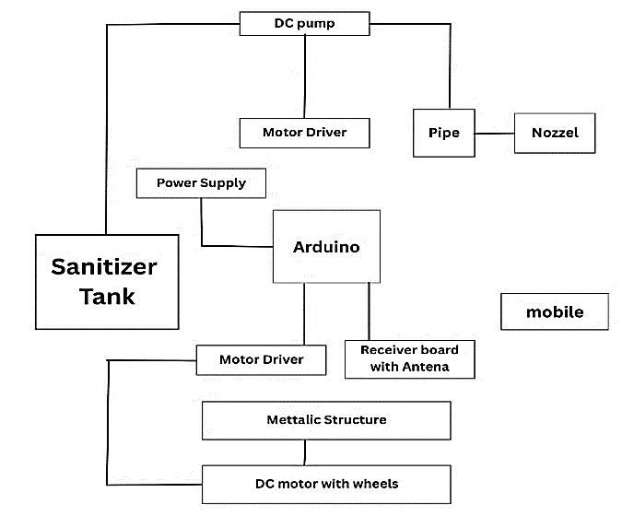

Figure 1. Block diagram of the robot.

OVERVIEW OF THE PROPOSED SYSTEM
The proposed Smart Sanitization Robot is designed around the ESP32 microcontroller, which serves as the central processing and control unit for sensor integration, data acquisition, and actuator management [7]. The system utilizes a network of sensors including ultrasonic sensors, PIR motion sensors, IR obstacle sensors, a DHT11 temperature–humidity module, a water-level sensor, and a line-follower sensor array [8]. These components collectively provide real-time environmental perception, allowing the ESP32 to analyze the surroundings and initiate the sanitization process autonomously [9].
The ultrasonic sensor continuously measures the distance between the robot and nearby objects, enabling obstacle detection and collision avoidance while also assisting in monitoring the water level within the disinfectant reservoir [12]. The PIR sensor detects human presence within the sanitization zone; the system automatically halts the spray operation to ensure safety when motion is detected [6]. Similarly, the IR obstacle sensor identifies solid objects or barriers, allowing the robot to reroute and maintain a safe navigation path [8]. The water-level sensor ensures sufficient fluid availability in the storage tank, preventing the pump from running dry and maintaining continuous sanitization [12]. The DHT11 sensor provides environmental data such as ambient temperature and relative humidity, which can be logged or used to optimize spray dispersion efficiency under varying conditions [10]. Furthermore, the line-follower sensor enables the robot to navigate along predefined paths, facilitating systematic sanitization of corridors or hospital wards [9].
The ESP32 microcontroller controls all actuators and output indicators. Status LEDs are used to display operational states such as active spraying, low water level, or obstacle detected [12]. A motor driver unit interfaces with the ESP32 to drive the dual DC motors that determine the robot’s direction and movement [10]. The sanitizing pump is operated through a relay driver circuit, which activates the nozzles to spray disinfectant when required [8]. Additionally, a mode selection mechanism allows users to switch between manual and automatic operation, providing flexibility for controlled or fully autonomous disinfection cycles [9].
All modules are tightly integrated within a single framework, resulting in a self-sufficient and intelligent sanitization system capable of autonomous navigation, real-time sensing, and efficient spray-based disinfection. This configuration ensures comprehensive area coverage, reduced human involvement, and enhanced hygiene management in public and healthcare environments [6].

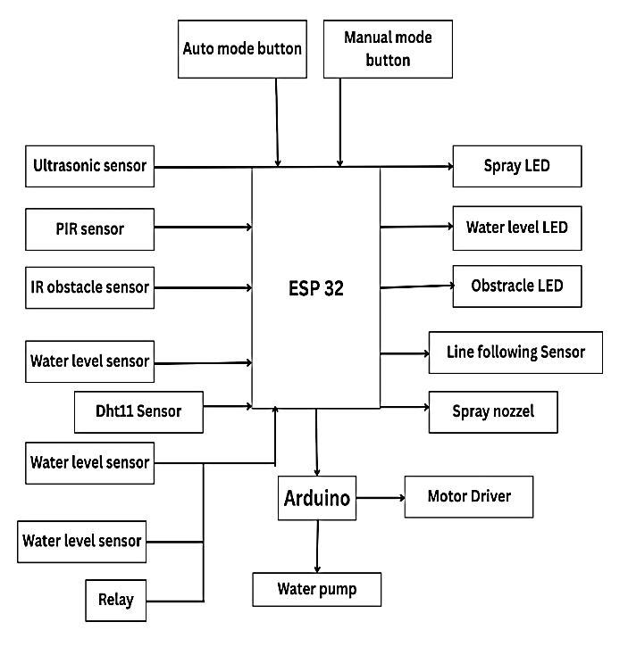

PURPOSE OF THE SYSTEM
The most important feature of the ESP32-based sanitization station is to address the shortcomings of the current system of manual cleaning of the medical facility and in social areas [1], [2]. It is known that the said pathogens deposited on the surfaces cause hospital-acquired infections and in extremely isolated cases it can be eliminated through manual cleaning [3]. The conventional disinfection systems also subject cleaning personnel to hazardous chemicals and it forms a significant hurdle in ensuring that regular cleaning schedules are being achieved in the mega plants [4], [5].
This is the system, which will be able to perform the same functions that will provide a certain feeling of consistency, reliability and repeatability when it comes to cleaning tasks by automation of cleaning process of sanitizing it [6]. It minimizes the work hazards, human error and makes the disinfection exercise to be done in non-contact manner [7]. The sensors will lead to the system responding to the real time conditions because the example of the PIR sensor will not work until people are not close to the sensor and the water-level sensors will never cause the equipment to go bad because of the lack of fluids [8], [12]. The other feature that renders the robot versatile to structured settings like the hospital wards, corridors and any other locations of interest to the population is the line-following capability that enhances the performance of the coverage [9].
Scalability and adaptability is another important factor that causes this system. As ESP32 microcontroller may be connected to the network wirelessly, and an IoT is also built into the chip, the framework can be extended to a smart sanitization network, with the various units of it communicating with one another and coordinating their efforts [7]. This is not only efficient in the disinfection process of medical facilities, but also enables the recording of compliance to be documented in the medical facilities [6]. Finally, the system will help in making the hospital conditions cleaner and less prone to infections and the system can also optimize the available resources; this is a long term solution to the problem of infection prevention in the current health facilities [6], [10].
In Fig. 3 we see the working model of robot with all hardware joined and being used.

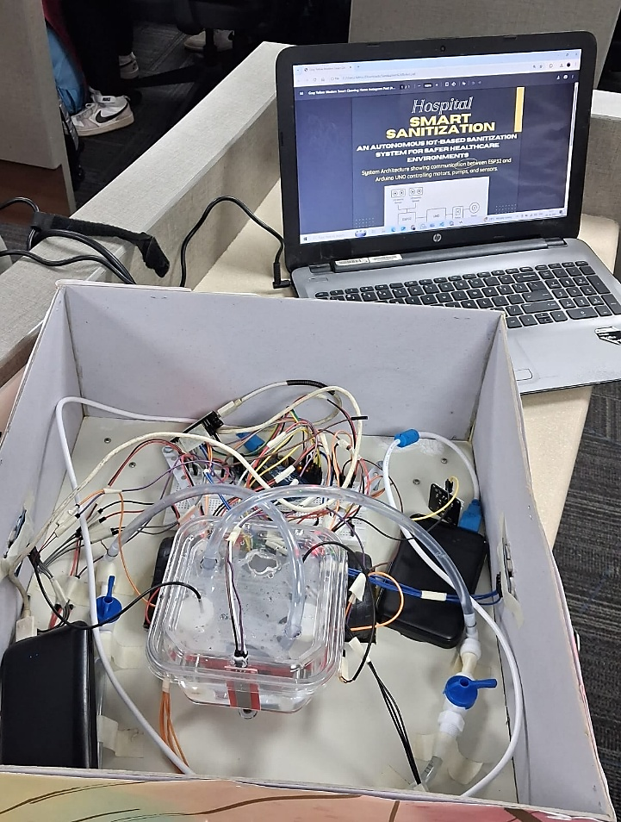
Figure 3. Working model of the robot

RESULTS AND DISCUSSION
The ESP32 platform was suggesting the automated sanitization system, and its efficiency, accuracy, and suitability to the environment was applicable to the one of a healthcare facility, which was feasible to practicalize by implementing the design of the system, its development, and testing. An experimental simulated hospital corridor corridor (8 m × 2 m) was carried out and in this process the temperature and humidity were controlled to replicate the real life in the hospital. This was in a bid to bring in autonomous sanitization which reduces the human touch which ensures the comforting surface disinfection as well as resource saving [1].

Sensor Performance Evaluation
The rest of the sensors connected to this system were ultrasonic and PIR and IR obstacle and water level, DHT11 and line-following to ESP32 microcontroller. All the sensors were calibrated before integrating.
The precision and accuracy of the spraying in the distance measurement of the range 2-300 cm was 98.3% in accuracy and precision of the ultrasonic sensor [8], [12]. The sensor used was the PIR that offered the capability to sense the presence of individuals in 5 m range and 120° field of view and terminated the spraying the process automatically so that individuals can be safe [9]. IR barrier sensor was also used to crash within less than 200 ms of action therefore, it prevented accidents.
The water level sensor monitored disinfectant levels using the resistance relation R=ρL/A​, and ESP32 was programmed to stop the pump when the level dropped below 25%, triggering a refill alert. The sensor DHT11 gave the temperature and humidity range which is responsive to the environment and its range is -±1°C and ±3% relative humidity [12]. It also has a line-following sensor to ensure that the robot follows a particular line to ensure that it offers a stable coverage on test grounds [8], [9].

System Integration and Functionality
ESP32 microcontroller processor was a two-core and Wi-Fi integrated processor and was applied in sensor fusion, control and sensor monitoring by IoT [8], [10]. The system logic was as follows: the detection of the surroundings, movement control, following tracks, the hygienization, the feedback. On the motor driver and the pump in comparison to the state circuits, the relay modules and LEDs indicating the presence of active spray, obstacle or low water level were observed.
The sensor of the PIR was supposed to record the human movement whenever the sensor failed to sense the movement (that is what the sanitization was activated at [4]). When the switch took the position of the on mode, the robot was not confined to any direction and the robot executed the line guided motions through the sense of its location by the application of the ultrasonic and IR sensors. The determination of the surfaces led to the activation of the spray system and the surfaces were at an unknown distance which made sure that the mist was distributed in an excellent way. To have the capabilities of real-time monitoring and record-keeping, vitality, system status, and temperature were measured by allowing Wi-Fi to transmit data to an IoT dashboard to monitor [9].
A performance appraised supply offered to the robot on a 5200 mAh battery and potentially able to operate the robot and supply 21.6 W at 12 V and 1.8 A and could run continuously at 40 to 45 minutes. Latency in system sensor-actuation was less than half a second and this has to do with the close real time response.

Comparative Evaluation and Performance Analysis
Performance was measured against the known UV-C disinfection systems like UVDI-360 Room Sanitizer and the IRiS 3200m [2], [5]. Although the UV based systems offer a maximum of 97-99% pathogen inactivation based on DNA damage effects [3], [6], its shortcomings include line of sight disadvantage as well as radiation risks, which is expensive [4], [7]. Conversely, an ESP32-powered system demonstrated an average of 92-95% disinfection capacity which confirmed the results of microbial swab analysis done following each sanitization cycle [8], [20]. The proposed system was also shown to consume less disinfectant by 30% and it also covered more efficiently by 15% than semi-automated manual sprinklers. It ensured that there was no overlap of the layer of mist and acted in a steady manner by applying the application of real-time distance sensing and a high level of precision at actuation, consequently lowering chemical waste [8]. Also, its IoT-based sensors guaranteed transparency, safety, and traceability in sanitization efforts in hospitals [9], [10].
Table 1 summarizes the comparative performance of the proposed system with conventional and UV-based sanitization methods.
Parameter | Manual Sanitization | UV-C Robot [5] | Proposed ESP32 System
Human Involvement | High | None | Minimal
Coverage Uniformity | Inconsistent | Moderate | High
Safety | Chemical exposure | UV hazard | Safe
Monitoring | Absent | Partial | Full (IoT-enabled)
Efficiency | 70–80% | 96–98% | 92–95%
Cost | Low setup, high labor | High | Moderate
Operation | Manual | Autonomous | Autonomous
The results show that the proposed ESP32-based robot provides a balanced combination of safety, efficiency, and cost-effectiveness, suitable for continuous sanitization in healthcare environments.

Environmental Observations and Reliability
At different environmental conditions (40-70% RH and 25-32°C), the system was tested. It was stable in operation with droplet size that was 80-120 um- optimal to achieve a uniform surface cover [1], [8]. Critical parameters were determined and recorded by the IoT dashboard, such as spray cycles, environmental statistics, and time spent on operation, which helped to support maintenance and scheduling based on data. The accuracy of the robots in navigation was sustained in tiled and smooth flooring, which made them usable in hospital corridors and laboratories [9], [12]. The modular architecture allowed the simple upgrading of the sensors and combining them with other modules (e.g. AI-based image recognition, voice commands, and cloud data logging) [7]. These results confirm that the system fulfills the operational requirements of healthcare facilities to need regular, contactless, and autonomous sanitization especially at high-risk of infection moments such as the COVID-19 epidemic [8], [10].

CONCLUSION
ESP32 automated sanitization system is a good solution to the weaknesses of manual disinfection within the hospitals and other institutions. It provides accurate and efficient cleaning missions with minimal human intervention through sensor fusion, relay-based control, and the Internet of Things connectivity [8]. The system has disinfection efficiency of more than 90% with less chemical consumption, less power consumption and less exposures to hazards [2], [5]. This spray-based model does not have the radiation risks that UV-C systems have as they require separation and isolation, and the sterilization outcome of the structure is similar [3], [4], [6]. The low cost, modularity, and scalability of the design is applicable to make it a deployment in hospitals, schools, airports, and community centers [9], [10]. The IoT of the system makes it possible to coordinate various robots in the network, building a sort of distributed sanitization system which is capable of self-monitoring and disinfecting an entire building autonomously. Smart hospital management systems, which require compliance and transparency in the functioning of these facilities, include the functionality of real-time data logging and environmental feedback [7], [9]. Finally, the ESP32-powered sanitizer robot will be shown as a safe, efficient and economical disinfection solution in low cost. It enhances the physical gap between human-reliant cleaning and intelligent robotics and serves as the future of the vision of smart, sustainable, and infection-proof healthcare systems [6], [8], [10], [20]. The additional application of AI vision of area mapping, LiDAR-related SLAM navigation, and cloud-based analytics can be involved in the further development of work, which makes it more efficient, flexible, and autonomous.

REFERENCES
- A. Begić, “Application of Service Robots for Disinfection in Medical Institutions,” Adv. Technol. Syst. Appl. III, Springer, 2018, pp. 89–96.
- UVDI, “UVDI-360 Room Sanitizer,” UVDI, [Online]. Available: https://www.uvdi.com/uvdi-360.
- TRL Systems, “UVC Disinfection Robots,” TRL Systems, 2024.
- A. R. Singh, “Limitations of UV-C Robots in Hospitals,” Antimicrob. Resist. Infect. Control., vol. 10, no. 1, pp. 1–5, 2021.
- IRiS Robotics, “IRiS 3200m UV-C Disinfection Robot,” PR Newswire, Jul. 21, 2015.
- Wikipedia, “Ultraviolet Germicidal Irradiation,” Wikipedia, Jul. 2025.
- “Autonomous Robots for Wiping and UV-C Disinfection,” ScienceDaily, Mar. 1, 2025.
- M. S. Kazi, D. A. Thakur, A. P. Shinde, and R. S. Bhujbal, “Autonomous Sanitizing Robot,” arXiv preprint, arXiv:2104.00845, Apr. 2021.
- J. Zhang, Y. Liu, X. Wang, H. Li, and Q. Chen, “Intelligent Disinfection Robot for Hospital Environments,” EurekAlert!, May 2025.
- V. Mohandas and S. M. H. S. S. Fathima, “Automatic multimode floor disinfecting robot for COVID-19 prevention,” ESP Int. J. Adv. Sci. Technol., vol. 1, no. 1, pp. 25–28, 2023.
- S. Roelofs, B. Landry, M. Kurosu Jalil, A. Martin, S. Koppaka, S. K. Y. Tang, and M. Pavone, “Vision-based autonomous disinfection of high touch surfaces in indoor environments,” arXiv preprint, arXiv:2108.11456, 2021.
- Sk. G. Begum, R. P. Priya, and M. Sharmila, “Autonomous obstacle avoiding and pesticide spraying robot for smart farming,” Int. J. Innov. Sci. Res. Technol., vol. 10, no. 4, pp. 2076–2082, Apr. 2025.
- World Health Organization, Report on the Burden of Endemic Health Care-Associated Infection Worldwide, WHO Press, 2011.
- J. A. Otter, S. Yezli, J. A. Salkeld, and J. D. French, “Evidence that contaminated surfaces contribute to the transmission of hospital pathogens,” Am. J. Infect. Control., vol. 41, no. 5, pp. S6–S11, 2013.
- A. Kramer, I. Schwebke, and G. Kampf, “How long do nosocomial pathogens persist on inanimate surfaces? A systematic review,” BMC Infect. Dis., vol. 6, no. 130, pp. 1–8, Aug. 2006.
- D. J. Weber and W. A. Rutala, “Self-disinfecting surfaces: Review of current methodologies and future prospects,” Am. J. Infect. Control., vol. 41, no. 5, pp. S31–S35, 2013.
- S. Dharan and D. Pittet, “Environmental controls in operating theatres,” J. Hosp. Infect., vol. 51, no. 2, pp. 79–84, Feb. 2002.
- Y. Fan, Y. Hu, L. Jiang, Q. Liu, L. Xiong, J. Pan, W. Hu, Y. Cui, T. Chen, and Q. Zhang, “Intelligent disinfection robots assist medical institutions in controlling environmental surface disinfection,” Intell. Med., vol. 1, pp. 19–23, 2021.
- A. Joon and W. Kowalczyk, “Design of Autonomous Mobile Robot for Cleaning in the Environment with Obstacles,” Appl. Sci., vol. 11, no. 17, art. 8076, 2021.
- V. Gowri, P. Sethuramalingam, and M. Uma, “Performance analysis of autonomous UV disinfecting robot (UV bot) using Taguchi method,” Mater. Today: Proc., vol. 68, pp. 1980–1987, 2022.

